

PARLIAMENTARY PROCEDURE TEAM
(550)

~FINAL~
STATE 2021
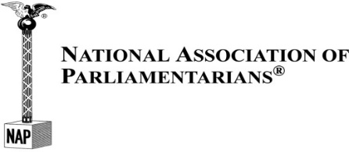

TOTAL POINTS __________
(Refer to Judge’s Scoring Rubric/Rating Sheets)

PARLIAMENTARY PROCEDURE DEMONSTRATION

The team will be allowed a preparation period of 15 minutes before giving a parliamentary demonstration to the judges. The team will be limited to a maximum of 15 minutes for parliamentary demonstration to the judges.

A blank 3" x 5" index card will be provided to each team member, which may be used during the presentation. In addition, the secretary will receive one blank sheet of paper to record the proceedings of the meeting in English, long hand for submission to the judges immediately after the presentation. The secretary will be permitted to take the contest agenda into the presentation room; this is to be submitted with the minutes to the judges.

The parliamentary authority, Robert’s Rules of Order Newly Revised (11th Edition), or any other reference materials, may be used in the preparation room but not during the parliamentary demonstration.

The items listed below are the order of new business for each subject listed. Items under “Abilities to be Demonstrated” may be rearranged within subject areas.

Subject | Abilities to be Demonstrated
- Visit State Legislature during session | - Main Motion
 | - Division of the Assembly
 | - Recess
 | - Parliamentary Inquiry
- Host teacher appreciation breakfast | - Main Motion
 | - Amend
- Commit or Refer
- Extend Limits of Debate
- Purchase appreciation gifts for advisor(s) | - Main Motion  - Point of Order  - Previous Question  - Request to Read a Paper

